Dear Editor,

We are pleased to submit a revised version of our manuscript (“*Survival, growth, and functional traits of tropical wet forest tree seedlings across an experimental soil moisture gradient in Puerto Rico*”) to be considered for publication in *Ecology and Evolution*.

We have addressed the constructive comments raised by the reviewers. Most critically, we (1) revised our main analyses to incorporate uncertainty in demographic metrics by using measurement error models, (2) developed text to address the value of using two separate demographic metrics (sensitivity and tolerance), and (3) assessing correlation between demographic metrics, within and among vital rates. All of these, as well as more minor revisions in response to all reviewer comments, are described in detail in our full response letter.

We are hopeful that you and the reviewers will find our new version suitable for publication. Please do not hesitate to contact us with any questions.

Sincerely,

Robert Muscarella, on behalf of co-authors

Plant Ecology and Evolution

Uppsala University

=======

**Detailed response to reviewers**

Note that the original reviewer text is in black, our replies are in blue.

**Reviewer: 1**

In this study, the authors assess the degree to which functional traits predict the growth and survival responses of seedlings of 8 tropical seedlings. Overall, I found the study to be well-written, interesting to read, and a valuable contribution to the literature. Specifically, a few strengths of the manuscript are the well-thought out experimental design and the comprehensive set of above and below ground traits used in the study. I commend the authors for their work and think this study makes a nice contribution to the literature.

My major comment is related to the analytical approach of how species-level sensitivity and tolerance are being predicted by species-level functional traits. In the current approach, tolerance and sensitivity of growth and survival are being estimated in a set of models and then these species-level values are then related to species-level functional traits with a linear regression. My main concern is that this approach does not adequately deal with the uncertainty in the estimates of tolerance and sensitivity and might inflate the confidence of the models by ignoring the uncertainty. For example, in Figure 4, there are no error bars for the species-level points, even though those values are estimated from a model and come with a corresponding level of uncertainty.

It may turn out that the results are the same regardless, but a more robust approach would be to use an approach that can propagate the uncertainty across the two modeling steps. One approach would be to use two-level hierarchical Bayesian model in something like Stan to property propagate the uncertainty. Another approach would be to take the species-level mean estimates and associated metric of uncertainty (e.g., SE, 95% CI) and use that as the response variable in a meta-regression model, with the functional traits as predictor variables in the meta-regression model, using a package like metafor - https://www.metafor-project.org/doku.php/metafor. There are likely other ways of dealing with this, but these are the two approaches that I’ve encountered to address this problem.

I’d encourage the authors to use an approach that can take into account the uncertainty in the species level estimates to produce a more robust statistical analysis.

We appreciate the overall positive feedback and detail our revisions below to address the reviewers comments.

With respect to this main point about incorporating uncertainty in our analyses, we have revised our analysis of the relationship between demographic parameters (sensitivity and tolerance) versus functional traits. First, we extracted standard errors for the estimated demographic rates to use in our regression models. In the revised manuscript, we say, “*To estimate standard errors for growth metrics, we used bootstrapping implemented with the ‘bootMer’ function in the lme4 R package (Bates et al. 2015). For survival metrics, we extracted standard errors of predicted values directly with the ‘predict’ function of the survival R package (Therneau 2020)*.”

Using the median and SE of these estimates, as well as the median and SE of the position of species along the trait ordination (RC) axes, we implemented a measurement error model in a Bayesian framework using the ‘brms’ R package [(Bürkner 2017)](https://paperpile.com/c/sZw9oP/KPcE). We used the specific approach detailed by Nicenboim et al. [(2023)](https://paperpile.com/c/sZw9oP/DOVe/?noauthor=1) and include additional details in the revised manuscript.

Briefly, the new models do not change our main conclusions. Based on 95% credible intervals of slope estimates, the same trends are statistically significant as with our previous analyses with respect to relationships between demographic metrics (average rates, as well as tolerance and sensitivity) and traits. Some relationships between individual traits and demographic metrics became non-statistically significant with this new analysis but the overall picture remains the same.

In summary, we appreciate this comment because we believe that our results and interpretation are more robust with this new approach. We have updated the methods and results sections, as well as Figure 4 and Table S9 to reflect these changes.

Line by line comments:

L45: Is the predicted decline in rainfall based on annual precipitation? It seems like seasonality or the timing of when the rains come is also a crucial component of the drought impacts. Consider adding information about the predicted impacts on the timing of rainfall.

We agree that timing of rainfall can be a crucial component of the drought impact, however we like to highlight that rainfall is generally considered aseasonal in our experimental site (l119-125). As a result, the emphasis of our study was how drought overall affects vital rates within different species, and timing of rainfall was not a major part of our experimental set-up. To help address this comment, we clarify our statement regarding the decline in rainfall in l44-46 and we now say: “*The Caribbean, for example, is expected to face a 5-50% reduction in annual rainfall by 2100 (Herrera & Ault, 2017; Mote et al., 2017; Ramseyer et al., 2019; Taylor et al., 2018).*“ In addition, we have revised and expanded the description of the precipitation regime of our study area in the methods section. We now say, “*Rainfall is aseasonal, with no month typically receiving <200 mm. Nevertheless, half of the annual precipitation occurs between August and December, with considerably drier conditions between January and March. Rainless periods of ~1 week are common (once per year, on average) while longer droughts (>2 weeks) have historically occurred every few years (Scatena et al., 2012). Long-term data show declining rainfall in the LEF (Moraes et al. 2022, Méndez-Lazaro et al. 2023), trends that are supported by modeling results (Ramseyer et al. 2019).*”

L47-48: Consider adding a few words here to explain to the reader why different species are predicted to have differential responses to drought

We now say, “*Different species are, however, likely to have different responses to the impacts of climate change due, in part, to differences in their ability to resist or avoid effects of drought.*”

L59: “demographic responses may manifest differently for different vital rates” is a somewhat confusing phrases, especially for a reader not family with demographic processes. Consider adding an example of what demographic compensation would look like to help illustrate this point.

We agree that this sentence was a bit confusing. We think it may be best to avoid mentioning demographic compensation directly here because the emphasis is that different vital rates may exhibit different responses to drought, not necessarily that vital rates will be compensatory. We now say, “*Additionally, different vital rates (e.g., growth and survival) may exhibit different demographic responses to drought (e.g., Yang et al., 2022), making it critical to evaluate multiple demographic rates for a more complete picture of responses to environmental variation.*”

L64-64: This is a great paragraph – well-researched and really nice background explanation. The only thing I felt was missing was the answer to the question of – well if all this is known about traits, what gap in knowledge is this study filling?

Thanks for the positive feedback! We have revised the last sentence of this paragraph to address this comment. We now say, “*Nevertheless, the role of traits in modifying various aspects of tree demographic responses to drought in tropical humid forests remains understudied and thus limits our ability to forecast the consequences of altered precipitation regimes on tropical forest ecosystems.*”

L121-123: Based on this information, it doesn’t seem like droughts are especially common or intense at the field site? It might be interesting to consider in the discussion how this might influence the results – would we expect different patterns at a site that regularly experiences much stronger seasonal droughts?

We have revised and expanded the description of the precipitation regime of our study area in the methods section to address this point. We now say, “*Rainfall is aseasonal, with no month typically receiving <200 mm. Nevertheless, half of the annual precipitation occurs between August and December, with considerably drier conditions between January and March. Rainless periods of ~1 week are common (once per year, on average) while longer droughts (>2 weeks) have historically occurred every few years (Scatena et al., 2012). Long-term data show declining rainfall in the LEF (Moraes et al. 2022, Méndez-Lazaro et al. 2023), trends that are supported by modeling results (Ramseyer et al. 2019).*”

L132: Could you provide more detail on what ‘local soil’ means? Given the importance of soil pathogens and plant-soil feedbacks in tropical forests, having more information about how the soil was collected and prepared would be helpful to the reader.

To clarify this point we now say: “*The soil we used was obtained from within 100m of the field station, which had similar properties to the soil at the experimental sites (JK Zimmerman, personal observations).*”

L134: What degree of shade was created by the shade cloth?

The shade cloth was 70% but was somewhat used and likely let through more light than when it was new. We have thus clarified this point in the text with “*(approximately 60-70% shading)*”.

L144: Just to clarify, how transparent are the SUNTUF roofs? How much (if any) additional shade to the make on the plot?

We have clarified this point and now say “*According to the manufacturers specifications the roofing material reduces light transmission by 10% (*[*https://www.palram.com/us/product/suntuf-diy-polycarbonate-corrugated-sheets/*](https://www.palram.com/us/product/suntuf-diy-polycarbonate-corrugated-sheets/)*)*”.

L148: What was the definition of a rain event used for the purposes of this study?

We now clarify this as “*rain event (greater than 5 mm precipitation over 24 hours).*”

L250: Consider reporting the correlation coefficients for intrinsic water-use efficiency and soil moisture here to mirror the reset of the results in this paragraph.

We revised this sentence to say, “*Four of six species tested (except P. montana and T. balsamifera showed significant negative correlations between intrinsic water-use efficiency (iWUE) and soil moisture (Figure S3, Table S4), suggesting that lower soil moisture indeed led to more integrated drought stress during the experiment (across all samples, Pearson’s r = -0.28, p=0.002).*”

L293: Consider reminding the reader here what RC2 represents.

The second half of the sentence achieves this point: “... *was positively correlated with RC2 (r=0.84, p=0.01) and three individual root traits (total length, depth and number of tips), which together reflect a more pronounced responses for species with larger root systems.*”

L309-311: The sentence here about the hurricane feels a little out of place. In my opinion, cutting this sentence and leaving the paragraph L365-374 is fine.

We deleted this line as suggested.

L318: Define CNDD here when it’s introduced. By the end of the discussion, I was expecting to read in a bit more depth about CNDD effects based on this statement, but did not come across anything else related to CNDD.

We deleted the mention of CNDD since it was speculative and tangentially related to our study.

L374: How would the impacts of the hurricane influence the results of this study?

We have expanded text in the discussion to address this point. Just before the conclusion, we say, “*The timing of our study relative to recent hurricane disturbance also needs to be noted. Specifically, our study began just over one year after Hurricane María, the strongest storm to affect the area in 89 years (Uriarte et al. 2019). Previous studies have shown the importance of temporal and spatial variation in light availability in the understory in determining seedling fate (Comita and Hubbell 2009, Uriarte et al. 2018). For example, Comita et al. (2010) documented how light availability varied after Hurricane Georges (1998) and how this temporal variation influenced overall seedling survival and the way in which it interacted, at times, with biotic factors such as the density of con- and heterospecific seedlings to determine survival. In our study, understory light levels were somewhat higher than typical for closed-canopy forests. By elevating understory temperatures, high light availability could exacerbate negative impacts of soil drought on seedling demography via a combination of more soil evaporation and increased water demands from elevated photosynthesis (Hogan et al. 2022). Overall, disturbance history provides important context for interpreting the results of the experiment and for making predictions about potential responses to compound disturbances in the future (Zimmerman et al. 2021).*”

Figure 1: I appreciate the figure to illustrate tolerance and sensitivity. To help the readability, I’d suggest lowering the survival probability of the blue species to around 75% at high soil moisture, so that it’s not overlapping with the red sensitivity bracket.

We revised this figure and legend for clarity. The new version of the legend text and figure is below.

***Figure 1.*** *Schematic diagram illustrating metrics of survival tolerance and sensitivity to soil moisture (an analogous approach was used for growth). The two curves show probability of survival as a function of soil moisture for two hypothetical species. We define 'tolerance' as the predicted probability of survival (or growth) at the 10th percentile value of soil moisture observed in our experiment. We define 'sensitivity' as the difference in predicted probability of survival (or growth) between the 90th and 10th percentile values of soil moisture observed in our experiment. In the diagram, the red curve represents a species with relatively high tolerance and low sensitivity to low soil moisture. The blue curve, in contrast, represents a species with a relatively low tolerance and high sensitivity to low soil moisture. The 10th and 90th percentile values of soil moisture correspond to 13.5% and 39.1%, respectively.* 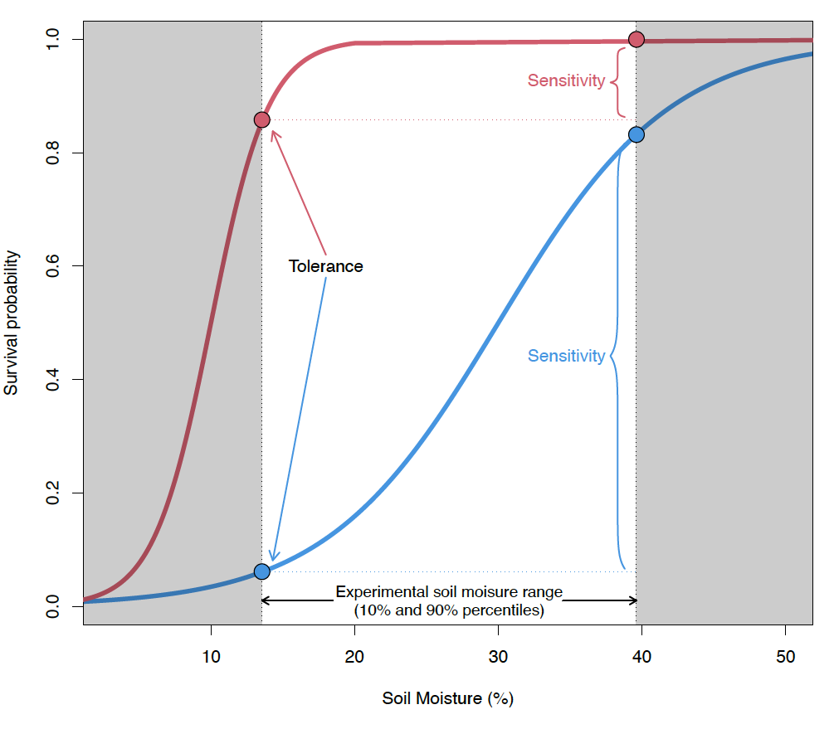

Figure 2: In both panels, are model predictions being made beyond the range of observed values of soil moisture %? It’s not clear from the graph is results are being extrapolated, but the results on L244 suggest that the lower bound of soil moisture observed was 9%, though the graph predicts survival probability out to 0%. I’d suggest that the authors only show predictions within the observed range of values for soil moisture, or to indicate clearly to the reader when extrapolation is happening.

We revised this figure as below to address these comments:

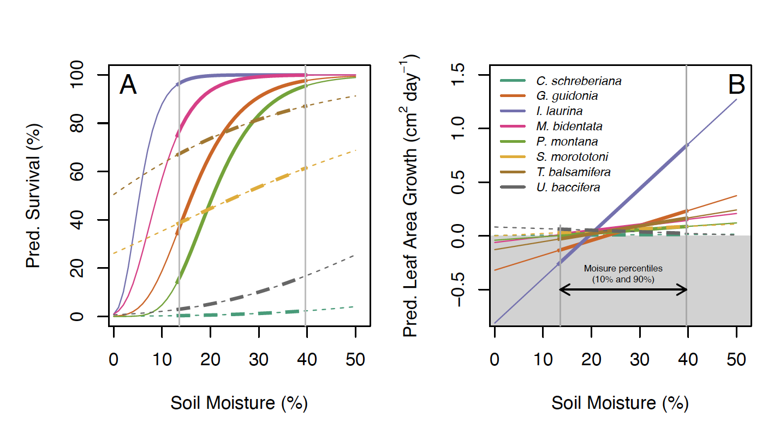

Figure 4: The ordering of the sub-panel letters is a little confusing, as most readers would expect to read ABC from left to right, rather than top to bottom.

We revised this figure according to suggestions from both reviewers, including that we incorporated error bars for the individual points and ordering of panels. The new version appears like this:

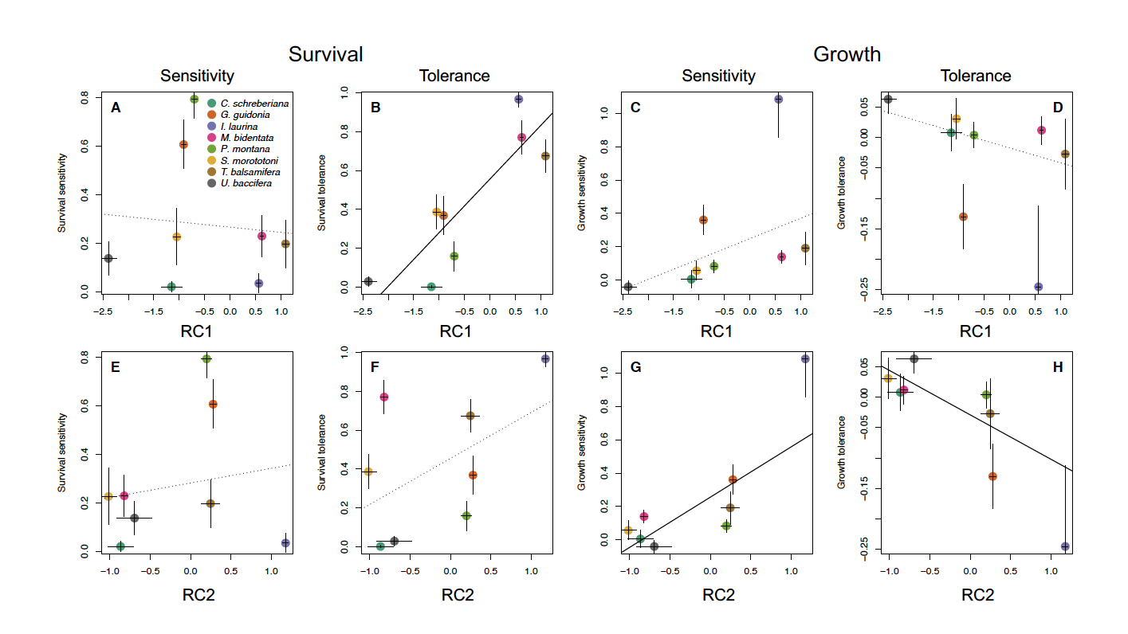

**Reviewer: 2**

In the manuscript, the authors present an experimental study into the effects of soil moisture on survival, growth and functional traits of seedlings in a wet tropical forest. Given the projected changes of rainfall patterns in the tropics, and the global importance of tropical forest ecosystems, this is an important and timely study. The experiment is very well-conducted, the data analyses solid, and the results provide interesting and novel insights into seedling responses to drought and the traits that mediate them.

The authors calculated for both survival and growth two different metrics: the rate at low soil moisture (termed tolerance, at lowest 10th percentile soil moisture), and the difference/change of the rate between high and low soil moisture (termed sensitivity, diff. between 90 and 10th percentile). I like this approach which offers insights into two different aspects of 'drought responses'.

We appreciate the positive feedback.

- from the hypotheses, it seems that a relation (trade-off?) was expected, i.e. conservative species have high tolerance but low sensitivity, and acquisitive species low tolerance but high sensitivity.

Indeed, we do suggest such a relationship but we refrained from explicitly testing this in our previous manuscript. We have now included a formal analysis of these correlations that includes measurement error of the demographic metrics (as suggested by R1 above). In the methods, we now say, “*To characterize relationships between metrics of demographic performance, within and across vital rates, we used linear regression to evaluate the correlation between sensitivity of survival and growth, tolerance of survival and growth, and between sensitivity and tolerance, for both survival and growth. To incorporate uncertainty in these comparisons, we implemented a measurement error model in the ‘brms’ R package (Bürkner 2017), as specified by Nicenboim (2023), that included standard errors of the demographic metrics (as described above). We used default settings and priors for model fitting and assessed model convergence using the Rhat statistic and visual inspection of trace plots.*”

- it would be interesting to actually explore, if/how the two metrics are related to each other, with and across the demographic rates (i.e. are more 'tolerant' species also less 'sensitive'?, and are species more tolerant in terms of growth less tolerant in terms of survival?). These questions have, as far as I know, not been explored, and the data could provide important insights.

Using the new measurement error models (see above response to R1 and response to previous comments), we examined correlations between sensitivity of survival and growth, tolerance of survival and growth, and between sensitivity and tolerance, for both survival and growth. Of these comparisons, only the relationship between growth sensitivity and growth tolerance was (negative) significant, which corresponds to an expected link between slope and intercept terms in a linear model (i.e., models with steeper slopes [more sensitivity] typically have lower intercepts [greater tolerance]). So, we find no strong evidence for correlations of the two metrics, within and across the demographic rates.

To help set up these comparisons, we added the following text to the introduction, “*Correlations among responses for different vital rates could reflect trade-offs that underlie demographic variation in diverse species groups (e.g., Russo et al. 2021).*”

Then, in the results, we say, “*We did not find strong evidence for correlations of the sensitivity and tolerance metrics within or across vital rates (Table S9). In particular, there were no significant correlations between sensitivity of survival and growth, tolerance of survival and growth, or between survival sensitivity and tolerance. Growth sensitivity was significantly negatively correlated with growth tolerance (Table S9), which corresponds to an expected link between the slope and intercept terms in linear models (i.e., more sensitive species [those with steeper slopes] had greater tolerance [lower intercepts]).*”

Finally, we added a short paragraph to the discussion about these results: “*Interestingly, and contrary to our expectations, we found no evidence for correlations between demographic metrics (sensitivity and tolerance) within or between vital rates, except for an expected correlation between growth sensitivity and tolerance that corresponds to a significant slope-intercept correlation for linear models. This result highlights the complexity of demographic responses to variation in soil moisture; across species, responses and thresholds to variation in soil moisture may vary for different vital rates. More work is required to untangle how complex demographic responses ultimately scale up to population-level consequences in diverse communities.*”

- in the intro, it would be especially relevant to explain why (not only that) it is important to explore these two different aspects, and what the different ecological repercussions might be. Especially, what are the implications of 'sensitivity'? Similarly, why is it important to address both growth and survival.

We have revised the introduction to address this point. Specifically, we say, “*One challenge for understanding how different species will respond to drought is the variety of ways to characterize demographic responses (Figure 1). For example, species may differ in their ability to survive or grow under extremely low resource conditions (e.g., periods of very dry soil) (Tilman, 1982). Species could also differ in the degree to which their demographic rates are sensitive to variation in environmental conditions. More specifically, the relative magnitude by which a given demographic rate varies across a relevant range of environmental stress can be used to characterize species responses (Engelbrecht et al., 2007). Additionally, different vital rates (e.g., growth and survival) may exhibit different demographic responses to drought (e.g., Yang et al., 2022), making it critical to evaluate multiple demographic rates for a more complete picture of responses to environmental variation. Overall, a solid understanding of species responses to environmental change requires a comprehensive evaluation of responses for multiple demographic rates.*”

- the discussion reiterates the results in relatively much detail (line 334 - 348, also 312-316), however, I am missing again a discussion of the ecological implications of tolerance vs. sensitivity (and that they are mediated by different traits). It seems to me that this should be the centerpiece of the discussion (while possibly shortening aspects like ontogeny, timing of the study etc.).

To address this point, we revised the discussion and elaborated on our results involving correlations between demographic metrics and multivariate trait axes. The most relevant section now reads, “*We separately assessed how traits are related to the ability of species to tolerate low soil moisture and the magnitude of responses of species across the soil moisture gradient (i.e. sensitivity). The multivariate trait axis (RC1) corresponded to an acquisitive/conservative trait spectrum; higher values of RC1 were associated with more conservative strategies (e.g. higher carbon investment in leaf and root tissue) (Köcher et al. 2012, Eldhuset et al. 2013, de la Riva et al. 2016). As hypothesized, we found a positive correlation between species-mean position along RC1 and species average survival as well as survival tolerance to low soil moisture, indicating that species with more conservative traits had higher survival tolerance to drought, which is generally consistent with prior work (Niinemets 2001, de la Riva et al. 2016, Tng et al. 2018). In contrast, sensitivity of survival along the soil moisture gradient was not significantly related to either RC axis, suggesting that the consequences of low soil moisture for differential survival across species may be more likely to manifest at certain thresholds as opposed to gradual differences in responses across a soil moisture gradient.*

*The second multivariate trait axis (RC2) reflected investment in below-ground tissue, with higher values associated with longer root systems, more root tips, and higher root-to-shoot dry mass ratio. Species with higher values of RC2 were less tolerant to low soil moisture in terms of growth, indicating that species with more extensive root systems had lower growth rates in drier soils. This finding is somewhat surprising in that, typically, plants with more extensive root systems have increased water absorption and nutrient uptake, as well as improve access to deeper soil layers, and thus may be particularly important for seedlings to survive during periods of low soil moisture. One possible explanation for our findings is that seedlings with larger root systems require more resources to maintain their root system, which come at a relatively high expense of above-ground growth. Notably, species with higher values of RC2 were also more sensitive to variation in soil moisture in terms of growth, suggesting that seedlings with more extensive roots could more efficiently capitalize on higher levels of soil moisture than those with smaller root systems. Although average growth rates were positively correlated with total rooting depth, we found no significant relationships between RC1 (the acquisitive-conservative axis) and either growth tolerance or sensitivity. In other words, the acquisitive-conservative resource axis captured by the traits we measured did reflect species-level differences in average growth but not variation in growth in response to the soil moisture gradient.*”

- Figure 1 together with the text in the methods (lines 229-237) explain the two metrics well. In contrast, I find the figure text (fig 1) as well as the explanations in the introduction (lines 54-60, 78-80) less clear.

We revised Figure 1 and the associated legend (please refer to response to R1 comment above).

- As Fig 1 is a schematic, the text could be simplified to refer to survival (rather than probability of...). Maybe it could be made more clear in the figure itself, that tolerance refers to absolute values, whereas sensitivity is a difference. Also, the same logic as for survival was also used for growth, which might be reiterated. Explaining the metrics again in Fig. 2 might not be necessary, if e.g. the same colors would be used for lines etc.

We maintain “probability of survival” on the y-axis of the schematic figure because (1) it matches the actual analysis, (2) since survival is a binary process, the fitted curves imply a probability, not overall survival. We have updated Figure 1 (also based on comments from R1 above) and we have revised the associated legend to be more clear.

- the abstract needs some rephrasing of the explanation of tolerance to be clear and correct (higher than what?).

We revised for clarity and now say, “*We quantified survival and growth over an eight-month period and characterized demographic responses in terms of tolerance to low soil moisture (defined as survival and growth rates under low soil moisture conditions).*”

- The discussion raises the aspect of successional status. A formal analysis (in the supplement?) would make this argument stronger.

We mention successional associations very briefly in the discussion in relation to another study but we would like to refrain from going deeper with this analysis in this study because we feel it would add additional complexity when the emphasis in our current study is on trait variation. So, we prefer to keep focused on the acquisitive / conservative trait framework and only mention successional associations with respect to this trait axis. We have deleted the reference to successional associations from the introduction and edited the relevant sentence of the discussion to read, “*Specifically, early successional species (which typically have relatively acquisitive traits) were less drought tolerant than late successional species (which typically have relatively conservative traits).*”

- The aspect of the major hurricane prior to the experiment is only raised in the discussion (line 309). It would be preferable to provide that information in the methods.

We added the following statement to the methods section when describing our canopy openness measurements: “*Note that our study area was impacted by a major hurricane (Maria) in September 2017 and canopy openness levels during our study were still somewhat higher than typical for closed-canopy conditions.*”

- the discussion the points out that the hurricane provides important context for interpreting the results (line 373), but it remains unclear how. I suggest to actually explain how the hurricane might have affected the results.

We have expanded text in the discussion to address this point. Just before the conclusion, we say, “*The timing of our study relative to recent hurricane disturbance also needs to be noted. Specifically, our study began just over one year after Hurricane María, the strongest storm to affect the area in 89 years (Uriarte et al. 2019). Previous studies have shown the importance of temporal and spatial variation in light availability in the understory in determining seedling fate (Comita and Hubbell 2009, Uriarte et al. 2018). For example, Comita et al. (2010) documented how light availability varied after Hurricane Georges (1998) and how this temporal variation influenced overall seedling survival and the way in which it interacted, at times, with biotic factors such as the density of con- and heterospecific seedlings to determine survival. In our study, understory light levels were somewhat higher than typical for closed-canopy forests. By elevating understory temperatures, high light availability could exacerbate negative impacts of soil drought on seedling demography via a combination of more soil evaporation and increased water demands from elevated photosynthesis (Hogan et al. 2022). Overall, disturbance history provides important context for interpreting the results of the experiment and for making predictions about potential responses to compound disturbances in the future (Zimmerman et al. 2021).*”

- line 319-320 refer to CNDD and to differential rates of growth and survival. Provide some detail on the argument why that may favor conservative species.

We agree that this argument was not well developed in the previous version. Although we feel this is a potentially relevant mechanism, we have deleted the reference to CNDD in this study because we do not actually assess it and we feel it would take too much text to develop the idea sufficiently.

- As far as I see, d13C was analysed according to standard methods (e.g. trait handbook) and used to represent long-term WUE, which is also standard. The respective section in the supplement should be removed and briefly integrated in the text. In a nutshell, decreasing d13C reflects a decrease of stomatal conductance, i.e. a direct physiological response to drought.

We have shortened this section to remove superfluous text. Indeed, the method has been used in other studies, but we feel it is important to retain certain details about the sampling design, the instruments and equations used for accreditation and reproducibility.

Minor points:

- line 85: remove or reword 'selective'

Our use of the term ‘selective pressure’ here follows recent synthesis of community ecology from Vellend [(2016)](https://paperpile.com/c/sZw9oP/JD9B/?noauthor=1). We do not see a reason to remove this term.

- line 335: rephrase to avoid circular argument; denser tissue were used to assign species and more conservative

We rephrased the sentence to say: “*In our study, the multivariate trait axis (RC1) corresponded to an acquisitive/conservative trait spectrum; higher values of RC1 were associated with more conservative strategies (e.g. higher carbon investment in leaf and root tissue) (de la Riva et al., 2016; Eldhuset et al., 2013; Köcher et al., 2012).*”

- Fig 4: I suggest to structure the panels clearer, e.g. through headers for survival vs growth and tolerance vs. sensitivity.

We revised this figure according to suggestions from both reviewers, including that we incorporated error bars for the individual points. The new version appears like this:



- in Table S7, refer to 'canopy openness' rather than the method ('densiometer').

Done (also corrected in Table S8).